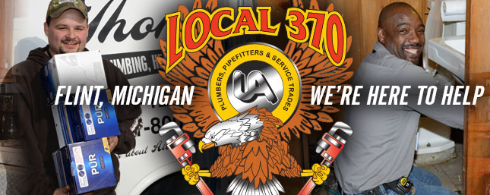
In Partnership with UA Local 370 Plumbers
Pipefitters and Service Trades

SHOWER FILTER GIVEAWAY - Pre-Registration Form

Name: Click here to enter text. Contact Number: Click here to enter text.

Address:Click here to enter text. Zip code: Click here to enter text.

Home Owner: [☐] Renter: [☐ ] Apartment: [ ☐]

- Have you had you water tested for lead? YES [☐ ] NO [☐ ]

- Are you a senior citizen? YES [ ☐] NO [ ☐]

- Do you have children under the age of 18 in the home? YES [☐ ] NO [ ☐]

- Do you currently have a water filtration system? If yes, check one
A. Sink filter [☐ ] D. All the above [☐ ]
B. Shower filter [☐ ] E. None of the above [☐ ]
C. Whole house filter [ ☐]

- Will you need assistance with installation? YES [ ☐] NO [ ☐]

I have agreed to submit this pre-registration by electronic means. By signing this registration electronically, I certify under penalty of perjury and false swearing that my answers are correct and complete to the best of my knowledge. I understand that an electronic signature has the same legal effect and can be enforced in the same way as a written signature.

Step. 1. Check the box below
☐ *By checking this box and typing my name below, I am electronically signing my registration.

Step 2. Type your name

Name: Click here to enter text. Date: Click here to enter a date.

EMAIL THIS FORM TO
hiphop4flint810@gmail.com

